**INEURON ASSIGNMENTS**

**Python Basics : Assignment 5**

## **Question 1:** What does an empty dictionary's code look like

**Answer**:

* An empty pair of curly braces {}

## **Question 2:** What is the value of a dictionary value with the key 'foo' and the value 42

**Answer**:

* {‘foo’ : 42}

## **Question 3:** What is the most significant distinction between a dictionary and a list

**Answer**:

* List allows duplicate items. Dictionary does not allow duplicate key values
* List is the sequence of items. Dictionary is the key: value pairs

## **Question 4:** What happens if you try to access spam['foo'] if spam is {'bar': 100}

**Answer**:

* As spam does not contains the key ‘foo’, it will throw error.

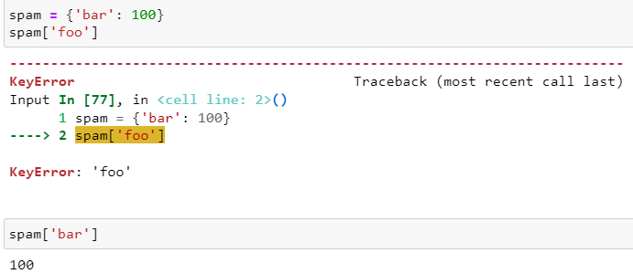

## **Question 5:** If a dictionary is stored in spam, what is the difference between the expressions 'cat' in spam and 'cat' in spam.keys()

**Answer**:

* Both expressions will return **True**. Both expression will check, whether ‘cat’ is present in key of spam dictionary.

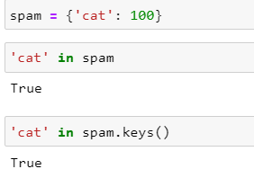

## **Question 6:** If a dictionary is stored in spam, what is the difference between the expressions 'cat' in spam and 'cat' in spam.values()

**Answer**:

* 1st expression will return True, as ‘cat’ is present in key of spam dictionary. Whereas, 2nd expression return False, as ‘cat’ is not found in values of spam dictionary.

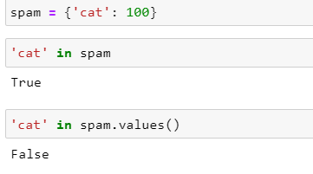

## **Question 7:** What is a shortcut for the following code

if 'color' not in spam:

spam['color'] = 'black'

**Answer**:

* spam.setdefault('color', 'black')
* setdefault() method to set a default value for a key in a dictionary if it doesn't exist

## **Question 8:** How do you "pretty print" dictionary values using which module and function

**Answer**:

* Using ‘pprint’ module and ‘pprint’ function, we pretty print the dictionary values.

